Building My Own Infrastructure AI Agent
Lately I've been learning how to build an AI agent from scratch.
I started with OpenClaw. It promised an agent that could work autonomously across all kinds of tasks. After a few weeks of using it, I wasn't satisfied.
OpenClaw felt too generic. It's built for broad use cases, while my needs were specific: managing infrastructure I actually own — DNS on Cloudflare, a VPS on Contabo, and a few services on AWS.
Instead of forcing a tool that didn't fit, I decided to build my own agent from the ground up.
I gave it limited access to read the state of my infrastructure. It can run a set of specific shell commands on the VPS (read-only), query the PostgreSQL database, check EC2 and S3 on AWS, and read CloudWatch logs. Later I added the ability to read GitHub repositories, and one write capability: creating new repos.
Because this agent touches production data, the first thing I built wasn't a feature — it was authentication. Only after that did I feel comfortable adding capabilities one at a time.
The stack is pretty simple.
The backend runs on FastAPI (Python), on the same Contabo VPS it monitors. The model is Claude, accessed through AWS Bedrock. Conversation history is stored in PostgreSQL, so the agent stays “aware” of context from previous sessions without starting from zero every time — which is also how I keep Bedrock costs down. The frontend is built with Astro, minimal by design, but it shows every step the agent takes in real time via streaming.
There's no heavy agent framework underneath. I wrote the loop myself: the agent gets a question, decides which tools to call, tool results get fed back to the model, and it repeats until it has a final answer.
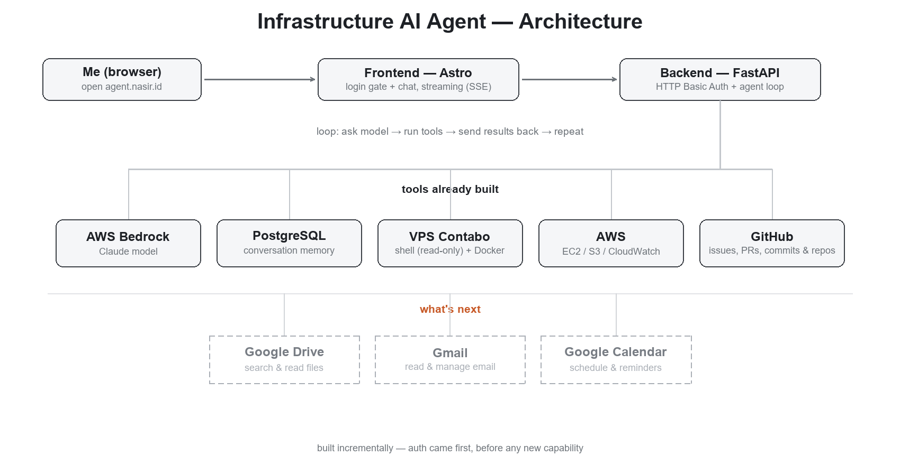
The architecture of the AI agent I'm building.
Next, I'm planning to integrate this agent with Google Drive, Gmail, and Google Calendar — so it's not just infrastructure, but something that helps with everyday work too.
I don't know yet whether building it myself will keep making sense as the complexity grows. But there's one thing I've already learned: building it yourself, even if it's slower than using something off the shelf, forces you to actually understand what's happening underneath it — instead of just being a user who takes it on faith.

